Experiment 8 - Association Mining using Python

| Roll No. |  |
| --- | --- |
| Name |  |
| Class | D15A |
| Subject | Business Intelligence Lab |
| LO Mapped | LO2:  Organize and prepare the data needed for data mining algorithms in terms of attributes and class inputs, training, validating, and testing files.  LO4: Implement various data mining algorithms from scratch using languages like Python/ Java etc. |
| Grade |  |

**Implementation -**

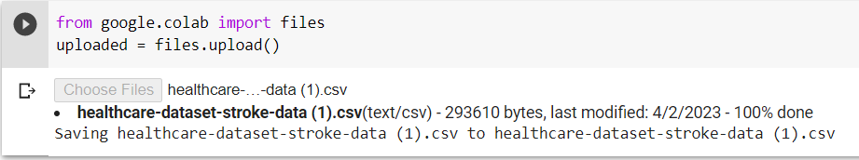

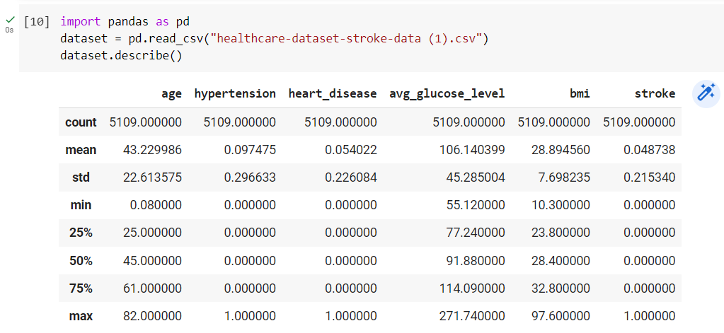



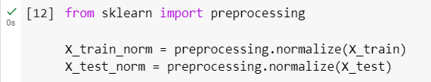

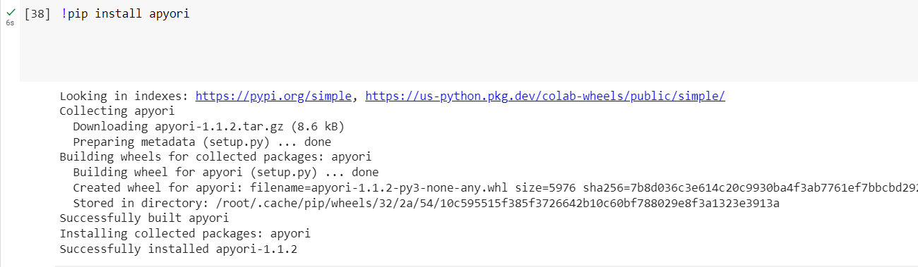

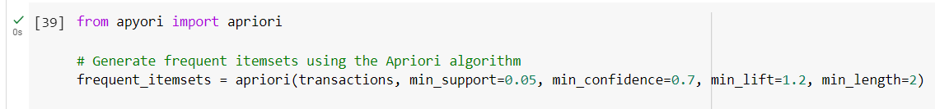

**Encoding columns to 0 and 1**

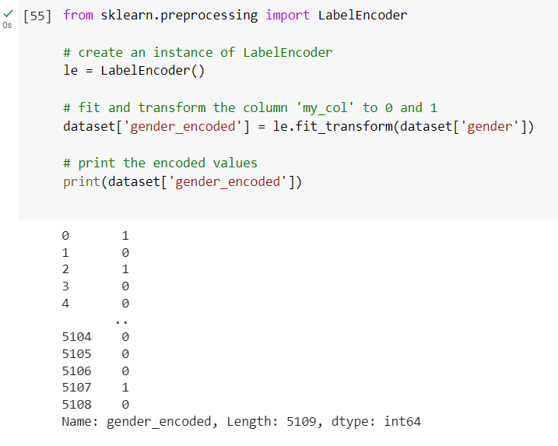

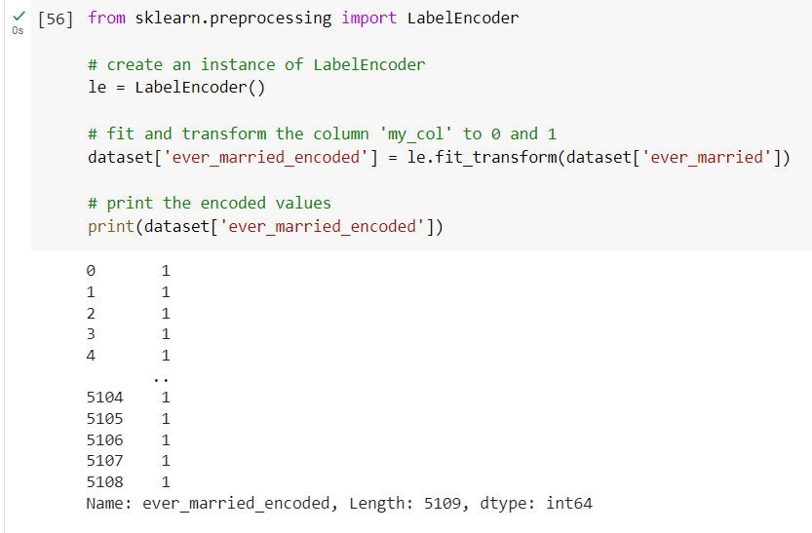

**Generating association rules**

